SCAT Street Cat Rescue
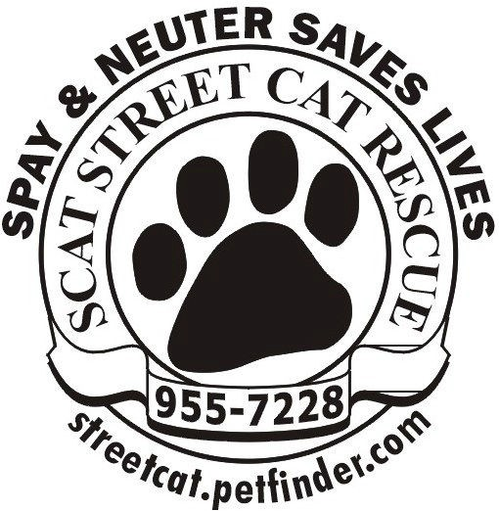
Volunteer Application
PLEASE PRINT AS CLEARLY AS POSSIBLE

Name
Address
City & Postal Code
Home Phone
Cell / Alternative
E-Mail Address
Usual mode of  transportation? | Please check one:  - Owned Vehicle  - Bus  - Other person

Are you over the age of 18? ___________________
Volunteers under 18 must be accompanied by a parent/guardian. If you are a minor, who will accompany you to volunteer? _______________________________________________________________

AVAILABILITY: During which hours are you available for volunteer assignments?

Weekday mornings

Weekday afternoons

Weekday evenings
Weekend mornings

Weekend afternoons

Weekend evenings

INTERESTS: How are you interested in volunteering? See descriptions on following page.

___ Petsmart Adoption Center (Preston Crossing) ___ Website maintenance
___ Main Center (50th & Faithful) ___ Cat & item transport
___ Volunteering at events
___ Fundraising
___ Fieldwork (trapping & colony care
___ Other ___________________________________________________________________________________________

Volunteer Opportunity Descriptions

Please note that the descriptions below provide examples of different volunteer tasks that are usually performed by a group of dedicated volunteers. Training and guidance is provided as required.

Petsmart Adoption Center: feeding, cleaning, monitoring and playing.

Main Center (50th & Faithful): Admin duties such as maintenance of lists, keeping track of applications, collecting donations, mailing tax receipts, etc.: feeding, cleaning and playing with the center cats in residence.

Volunteering at events: Helping with set-up and take-down at various events, selling items and taking donations, interacting with the public and cats we bring to events.

Fundraising: Organizing or looking for fundraising opportunities, such as dinners, galas, bbqs, and/or other events, communicating with all participants, selling tickets, etc.

Field Work: Monitoring feral cat colonies, delivering food, trapping cats requiring medical assistance, etc, reporting any issues to the center, working with property owners and public to bring awareness and obtain support.

Website Maintenance: Assisting with the updating and maintaining the SCAT web site.

Foster Home: Fostering cats for adoption, feeding, monitoring health, arranging for vet. appointments, etc.

Transportation: Transporting cats and their fosters for vet. appointments, arranging pickup and delivery of cat food donations, traps, items for auctions and other events.

Do you have any special talents or skills you want to share to benefit the cats?
(Ex: Occupation or hobby such as baking, photography, crafting, data entry, etc.)

Previous volunteer experience
Summarize your previous volunteer experience.

Summarize your previous experience with animals.

Person to notify in case of emergency

Name
Relationship to you
Home Phone
Cell / Work
E-Mail Address

Our Policy
It is the policy of this organization to provide equal opportunities to any or all who apply to volunteer and to provide a comfortable and friendly environment for people as well as cats. Thank you for completing this application form and for your interest in volunteering with us.

Agreement and Signature
By signing this application, I agree
    - To follow the policies and procedures of the organization
    - To treat all other volunteers and staff of the organization with respect
    - To comply with the laws and regulations
    - Not to knowingly give false information at any time, and
    - To receive email communications from SCAT.

I understand that if, at any time, in the opinion of the officers of the organization my behavior and/or my failure to follow policies and procedures jeopardize the well-being of the organization, I may be dismissed from my volunteer work with this organization.

Name (printed)
Signature
Date

